June 8
Michael, I would like the following edits to http://sub47-86.uhh.hawaii.edu/rmi-agroforestry/calendar.php
* edit text as shown below
* make the circle figure larger/wider if possible - fully utilize screens
* In the table, label the blue rain bar as “rainy” (dark blue) and “dry” (light blue)
* In the table, make the word “rain” a hyperlink to the Majuro/Kwajelein graphs on our “El Nino Pattern” page
* In the table, label the wind bar as “windy” and “less windy”
* In the table only, add a bar for “tropical storm probability” as shown below – no need to add to circle
* In the table only, add a bar for “wave train probability” (data & labels shown in table below)

*For all the crops: instead of “harvest time” and “no harvest,” label the bars “more harvest” and “less harvest”
* Colors: make breadfruit green-to-white (like rak). Make pandanus yellow-to-white (like annonean). For the other crops, use unique colors, like red, purple.
* Add a ring for “perennials” that goes all the way around
* Adjust breadfruit and pandanus using the numbers below to determine the shade (ring and table bar), but don’t show the numbers.
* In the circle create a combined ring “Arrowroot and giant taros” using numbers below. In the table, keep them separate.
* Add a ring for “True Taro” using numbers shown below
* Show full English/Marshallese names to label the bars in the table, as shown below. Hyperlink the MARSHALLESE names unless otherwise indicated. I might come back later and provide different hyperlinks for the English names.

Marshallese agroforestry calendar – normal yearsThis is a generalized calendar for “normal” years.
- The Marshallese year is divided into two major seasons, Añōn Rak and Añōneañ.

- The calendar focuses on harvest times of traditional crops, because they are perennial.
- This calendar shows how wind, waves and rain change during the seasons of an “average” year. Agroforestry recommendations are similar for “average,” neutral or La Nina years. The calendar is circular because the patterns generally repeat unless there is an El Nino. A different calendar is shown for El Nino years at [link].
- This calendar is very general for the Marshalls. Each atoll could have its own calendar, since the northern atolls are drier.

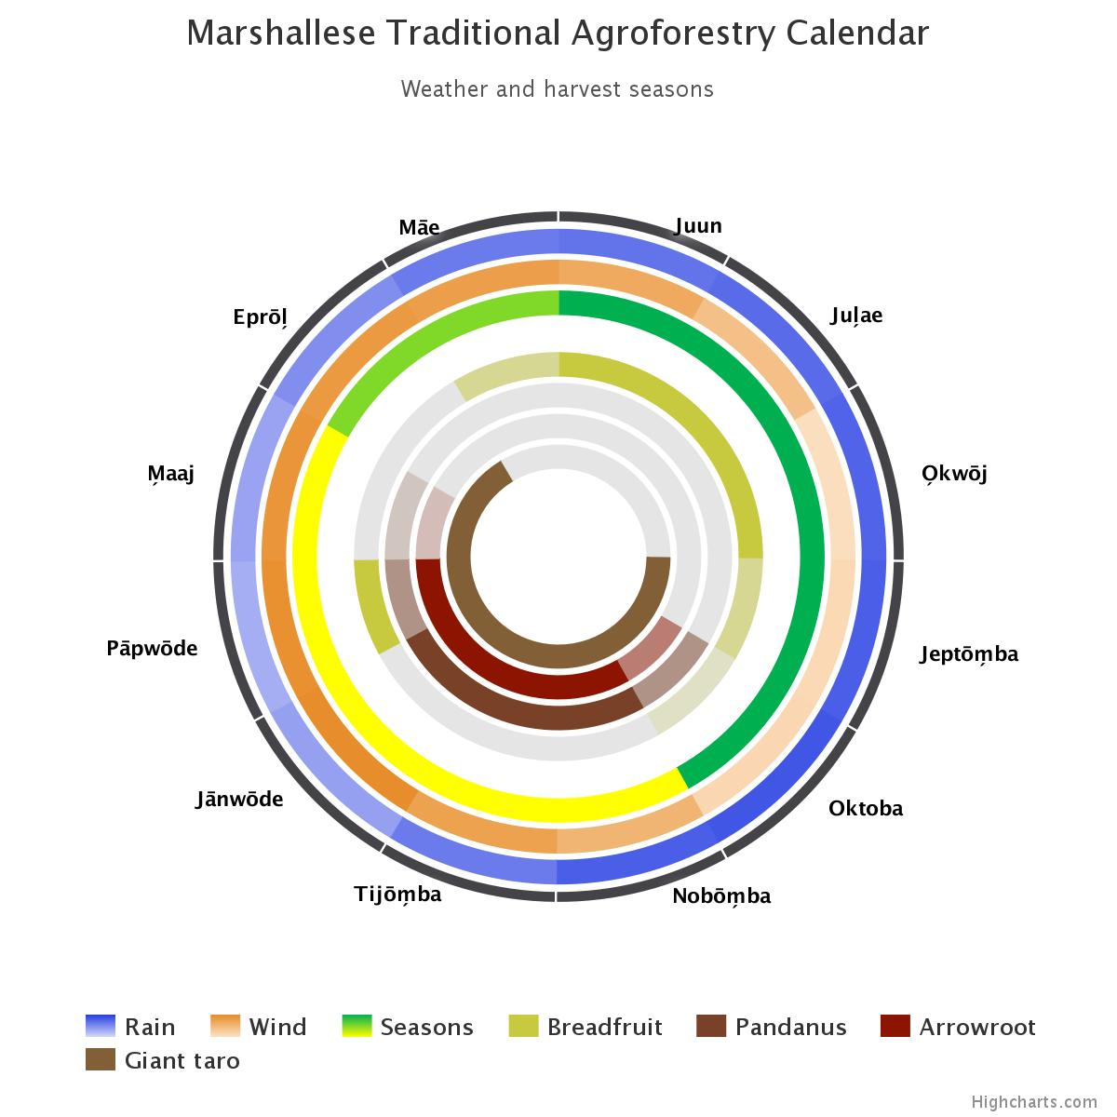
[Michael, insert the following table so that people see it when they scroll down from the above graphic on this page.
- Please make the colors in the chart the same colors as used in the circular calendar, and after you’ve got the colors right, delete the Dots and pluses.

 |  | Juun |  | Jul̗ae |  | O̗kwōj |  | Jeptōm̗ba |  | Oktoba |  | Nobōm̗ba | Tijōm̗ba |  |  | Jānow̄de |  | Pāpwōde |  | M̗aaj |  | Eprōl̗ | Māe
Named seasons |  | Rak (Summer, Wet) |  |  |  |  |  |  |  |  |  | Anonean (Winter, Dry) |  |  |  |  |  |  |  |  |  | Transition
Breadfruit (Mā, Mejwaan) |  | 9 |  | 9 |  | 8 |  | 5 |  | 2 |  | 2 | 2 |  |  | 0 |  | 3 |  | 4 |  | 4 | 6
Pandanus (Bōb) |  | 2.00 |  | 2.00 |  | 4.00 |  | 6.00 |  | 7.00 |  | 8.00 | 8.00 |  |  | 8.00 |  | 7.00 |  | 6.00 |  | 2.00 | 2.00
Arrowroot (Ṃakṃōk) |  |  |  |  |  |  |  |  |  | + |  | • | • |  |  | • |  | • |  | +
Giant swamp taro (Iaraj)  giant land taro (Wōt) |  |  |  |  |  |  |  | • |  | • |  | • | • |  |  | • |  | • |  | • |  | •
“Arrowroot and giant taros” |  | 0 |  | 0 |  | 0 |  | 1 |  | 2 |  | 3 | 3 |  |  | 3 |  | 3 |  | 2 |  | 1 | 0
True taro (kōtak) |  | • |  | • |  | • |  | + |  |  |  |  |  |  |  |  |  |  |  | + |  | + | •
Perennials | Coconut (ni)  banana (keeprañ) | • |  | • |  | • |  | • |  | • |  | • | • |  |  | • |  | • |  | • |  | • | •
Average wind direction & speed in knots |  | 12.1 (NE) | 9.5 (NE) |  | 5.6 (E) |  | 6.3 (E) |  | 6.5 (E) |  | 10.9 (NE) |  |  | 13.2 (NE) | 15.7 (NE) |  | 15.3 (NE) |  | 14.8 (NE) |  | 14.2 (NE) |  | 13.7 (NE)
Neutral/La Nina – Tropical storm probability |  | Almost no risk
Wave train probability (any year) |  | More likely |  |  |  |  | Possible

Other planting or harvesting calendars can be created for different crops and different atolls.
“Availability of Fruits and Vegetables in Majuro” by Kusto & Aikne

